**Version control System (VCS) :**

**Version** : Helps to track the changes happening to a software/code over the period of time.

Type of Version Control System :

1. Local VCS (SCCS)
2. Centralized VCS (SVN/TFS/CVS)
3. Distributed VCS (GITHUB/GIT LAB/BIT BUCKET)

**1.Local VCS (SCCS) :**

* We can loose the all version tracking change when developer machine crashes.
* Version tracking only on Developer machines.
* Collaboration between multiple developer is not possible
* Below mentioned diagram we have installed the SCSS tool in the developer machine.

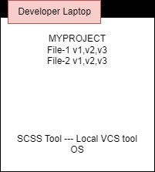

**2.Centralized VCS (SVN/TFS/CVS):**

* Version tracking happening only one remote machine.
* Collaboration problem is solved.
* If we loose the remote server then a chance to loose the version tracking.

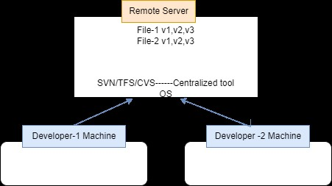

**3.Distributed VCS (GIT HUB/GIT LAB/BIT BUCKET) :**

* Version tracking happens in remote and developer machines.
* Dev make change in local and then push to remote machine when needed.

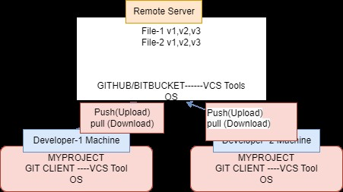

**GIT Commands :**

Git is a DevOps tool used for source code management/Version Control system. It is a free and open-source version control system used to handle small to very large projects efficiently. Git is used to tracking changes in the source code, enabling multiple developers to work together on non-linear development.

Project Name : Todayproject_04052023

Note : We need to the create our project directory. Enter into the directory and work on that directory

git init =====> To initialize the local git repositery

git status =====> To get the status

Explanation : Create the project directory and change that particular direction after on words need to run the git init command below screen shot I create the Todayproject_04052023 directory and git init run.

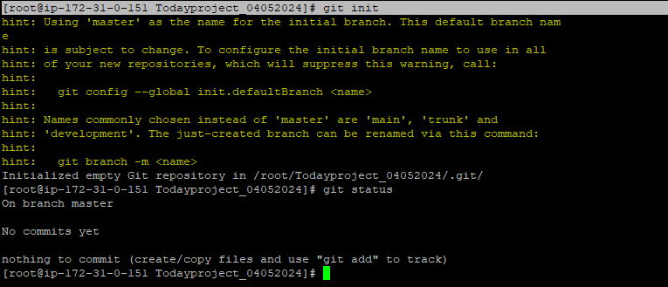

=================================

**How to add the user in Git**

Command : git config --global user.name <username>

Ex : git config --global user.name siva

=====================================

**How to add the user mail id in Git**

Command : git config --global user.name <maild id>

Ex : git config --global user.email siva@gmail.com

======================================

**List out the Users and Email id’s**

git config --global –list

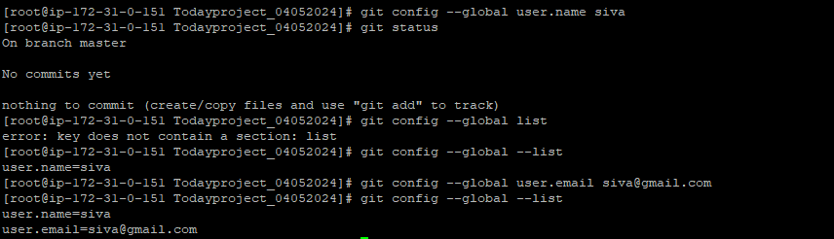

======================================

**How to add/Commit the new file or modified file in Git**

Create/Modify the files in the project directory.

Command : git add <file Name>

Ex : git add application.txt

[root@ip-172-31-41-212 FIRST_PROJECT]# git add application.txt

Once add the file need to commit.

Command : git commit -m "some content"

Ex : git commit –m “application file created”

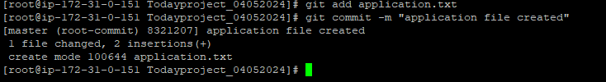

========================================================

How to get the Logs for after commit the file :

Command : git log

Ex : git log

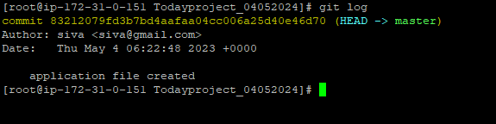

**Note : HEAD is the recent commit ID**

=======================================================================

**How to add the modified/added/deleted content in file with git.**

Step 1: First modify the data.

vi property.txt

Step 2: check the git status and if modified file not added into the git. It will says changes not staged for commit (staged means add stage)

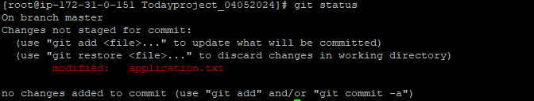

Step 3: add the file in git after modified/added/deleted content in file

Command : git add <filename>

git add application.txt

Step 3: Commit the file in git

Command : git commit -m "some content"

Ex : git commit –m “modified the application file”

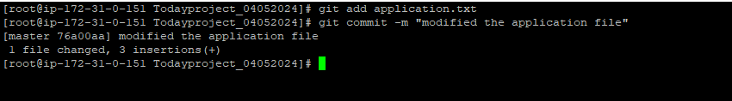

Step 4: Get the logs in git using below command

Command : git log

In the below screen shot output got created the application file and after that modified the application file. Both details we got.

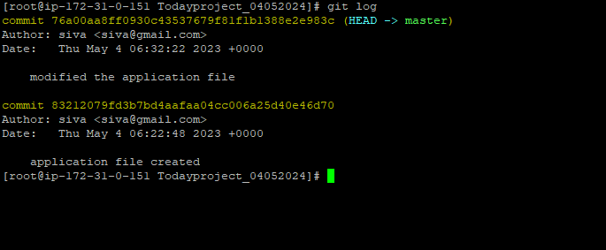

=======================================

**How to get the commit ID details.**

Commit Id is unique id for all changes . When ever we changes in the project after commit we will git every commit id.Using commit Id we can get the change details

Command : git show <commit ID>

Ex :

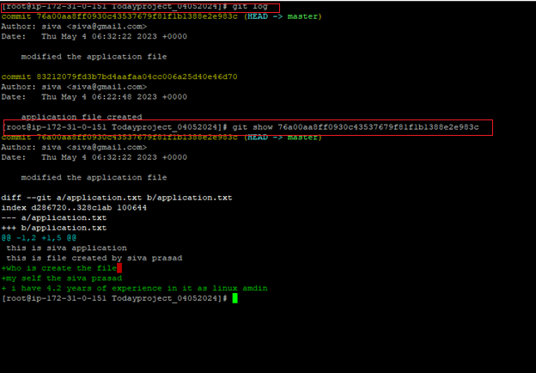

==================================================

How to add the multiple files in git

Command : git add .

Ex : git add .

How to revert the any changes in git.

For example I have created the new file name is today.txt and modified the existing file.

Command : git revert <commit ID>

Ex :

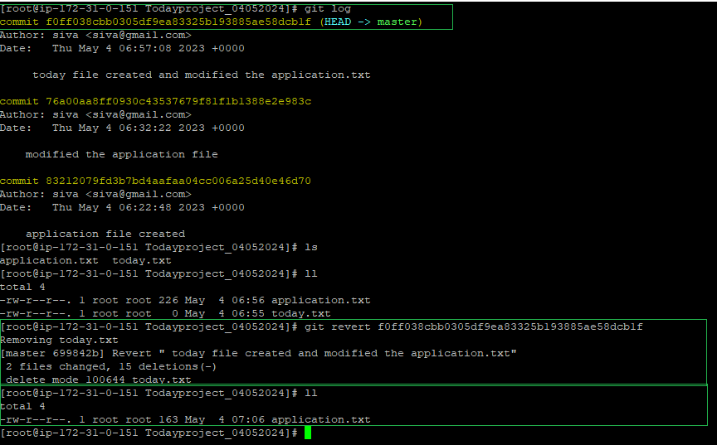

Note : while reverting the changes in git this one also create the commit id.

In the above screen shot

How to get the logs out put in one line.

Command : git log --oneline

Ex : git log –oneline

Command : git log –n 3 --author siva

How to create the tag

Commannd : git tag -a <Version number> -m <some content>

How to delete the tag

Command : git tag –d <tag name>

Ex : git tag –d V_3.1

How to check the server connected to remote repository.

Command : git remote –v

How to add the repository in local server.

Step 1: Login the git and create the repository

Step 2: Copy the push existing url in git.

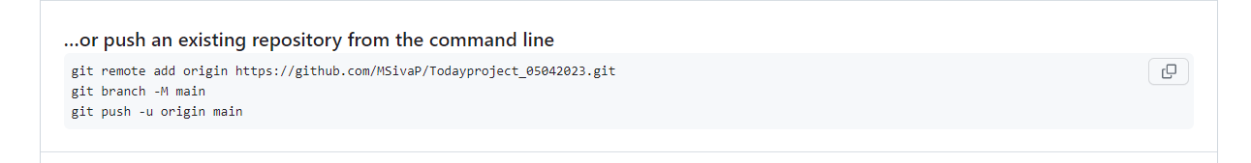

Step 3: Login to the local server and check the existing repository.

Command : git remote –v

Step 4: Add the repository in local server using below command.

Command :

git remote add <alias name> <url>

Ex :

git remote add origin <https://github.com/MSivaP/Todayproject_05042023.git>

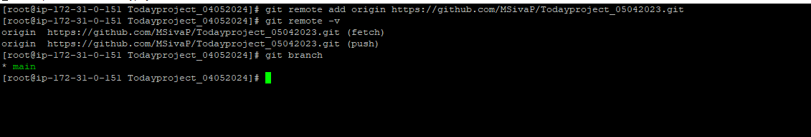

Step 5: After adding repository in local server we need to change the branch name

Command : git branch –M <branch Name>

Ex : git branch –M main

How to push local project data in repository.

Here : repository alias name is : origin Branch Name is : main

Step 1: check the repository name and branch name in local server.

Command : git remote –v ========> checking the repository alias name

Command : git branch ========> checking the branch name

Step 2: Push the data into repository and use below command.

Command : git push –u <alias name of repository> <Branch Name>

Here we will user name and password(token value need to enter)

Ex :

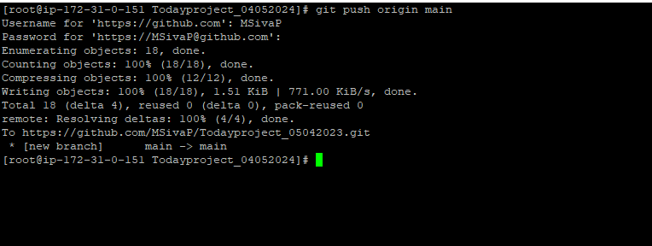

How to push tags local to repository?

Here :

Repository alias name is : origin

Branch Name is : main

Step 1: Login to the local server(Machine)

Step 2: Run below command

Command : git push –u <alias name> <branch name> --tags

Ex : 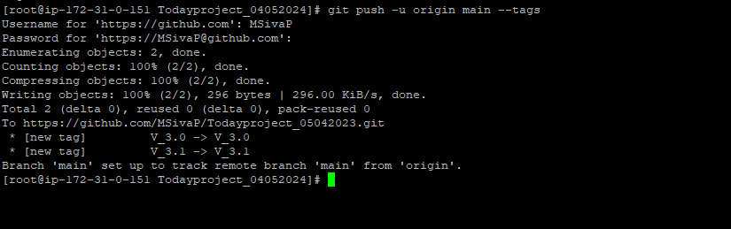

**How to push the data without password less in git.**

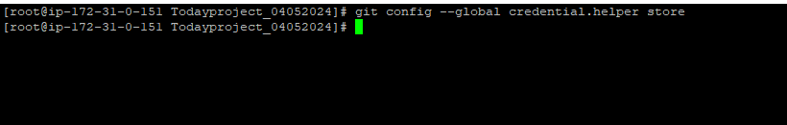

**How to pull the repository data into the new developer server?**

**For the first time need to pull use clone command.**

**Command :** git clone <repository Url>

What is fork and clone

Fork : It is a copy in remote server from my account to another account

Clone : It is a copy of our project from remote server to local server.

**What is difference git fetch and git pull.**

Git fetch only update in the .git references

Git pull will update the changes local changes and git references.

**What is branch and to check all the branches in remote as well local.**

In Git, a branch is a new/separate version of the main repository.

git branch ===== > to show only local branches

git branch –r ==== > to show all remote branches

git branch <branch name> ==== > create the branch in the local server.

git checkout –b <branch name> === > create the branch name and switch to that branch

Ex : git checkout –b test_2 ==== > to create the test_2 branch and switch test_2 branch.

git branch –d <branch name> ==== > To delete the branch

**Note : current running we can delete some other we can delete**

git branch –D <branch name> ==== > to delete the branch forcefully

**Build code :** converting the source into the deployable / installable format.

We can not use the source code for deploying in the server level .We need to convert the source into build code and then we can deploy the build code in the server.

**How to Build code :** We have build tools.

* Java --- Maven/ant/gradle
* .net -- ms build
* Python – pybuild

Git

Source code

**What are the various steps/stages involved in build code process?**

1. **Mvn compile --- >** Converting the high level lan to machine level language
2. **Mvn code review -- >** validating the code and check the mistakes in the code.
3. **Mvn unittest -- >** individual code testing (classes,functions) tested by developer.
4. **Mvn code coverage --- >** % to code coverage under testing.
5. **Mvn package -- >** In this level source code convert the deployable or installable format.

**Who perform the build code stages 🡺** Build tools like mvn, perform the above stages.

* Automate the above the thing with help of Jenkins :
* **Jenkins** tool can help to automate the build code process
* Jenkins is known as build code process / Continuous integration server.
* Build code process called as continuous integration process (**CI process)**

**PIPE LINE :**

* If run the above stages in build codes process in sequence order without manual intervention then it call as **PIPE LINE.**
* **Build code process === Continuous Integration process = CI PIPE LINE**

**How to build the source code into build code format using mvn manually.**

**Step 1:** Download the source code from Git or dev team will share the source code.

Step 2: Perform the mvn compiler using mvn compile command.

Mvn compile

Step 3: Perform the mvn unit test using mvn test command.

Mvn test

Step 4: Build the source code into build code using mvn package command.

Mvn package

**Note : Go to inside the source code directory and then form the all above stages.**

**How to convert the source code into build code using Jenkins CI pipe line.**

**Step 1:** Install the jdk package (For Ubuntu os use below mentioned commands)

sudo add-apt-repository ppa:openjdk-r/ppa

sudo apt-get update

sudo apt-get install -y fontconfig openjdk-11-jre openjdk-11-jdk

Step 2: install the maven.

cd /tmp ; sudo wget https://dlcdn.apache.org/maven/maven-3/3.9.4/binaries/apache-maven-3.9.4-bin.tar.gz

cd /tmp ; sudo tar -xzf apache-maven-3.9.4-bin.tar.gz -C /opt/

mv /opt/apache-maven-3.9.4 /opt/maven

sudo echo "MAVEN_HOME=\"/opt/maven\"" >> /etc/profile

sudo echo "PATH=\$MAVEN_HOME/bin:\$PATH" >> /etc/profile

source /etc/profile

Step 3: Install the Jenkins

curl -fsSL https://pkg.jenkins.io/debian-stable/jenkins.io-2023.key | sudo tee /usr/share/keyrings/jenkins-keyring.asc > /dev/null

echo deb [signed-by=/usr/share/keyrings/jenkins-keyring.asc] https://pkg.jenkins.io/debian-stable binary/ | sudo tee /etc/apt/sources.list.d/jenkins.list > /dev/null

sudo apt-get update

sudo apt-get install jenkins

sudo echo "MAVEN_HOME=\"/opt/apache-maven-3.8.5\"" >> /etc/profile

sudo echo "JAVA_HOME=\"/usr/lib/jvm/java-8-openjdk-amd64\"" >> /etc/profile

sudo echo "PATH=\$JAVA_HOME/bin:\$MAVEN_HOME/bin:\$PATH" >> /etc/profile

source /etc/profile

Step 5: Restart the Jenkins service using systemctl command.

Systemctl restart Jenkins

Step 6: Take server public ip and use search the below mentioned url in chrome

<http://serverippublicip:8080>

Step 7:

**How to set pipe line to convert the source code into build code.**

**Step 1:** Compile the source code using Jenkins tool.

**Step 2**: Code review

mvn --version

git --version

/opt/maven/bin/mvn –P metrices pmd:pmd

**Step 3: Unit test**

Mvn test

Postbuild 🡺 select the

**Step 4:** code coverage

Mvn verify

Postbuild 🡺 select the jacoco plugins.

**Step 5:** code package

Mvn package

Step 6: Kindly do the below mentioned changes in all build formats.

**select the unittest 🡺 configure 🡺 build triggers 🡺 Build after other projects are built 🡺 select the compile and then save**

**select the codecoverage 🡺 configure 🡺 build triggers 🡺 Build after other projects are built 🡺 select the unittest and then save**

**select the package 🡺 configure 🡺 build triggers 🡺 Build after other projects are built 🡺 select the codecoverage and then save**

Step7: Go to home page and then select the create the pipe line using ‘**+’** symbol then

NEW view 🡺 select the type Build pipe line 🡺 create the new pile line 🡺 select the initial job here need to select the compile